**Dungeness SONAR Data Review Protocols**

**Overview**

1. **Create echograms**
2. **Review and record data**
3. **Keep track of data review progress, save data**
4. **Create echograms**
5. *Open ARISFish and open a file to view*. Files -> Open Recently Reviewed -> select a folder (day/date) to review, and select a file with the .aris extension within the daily folder.

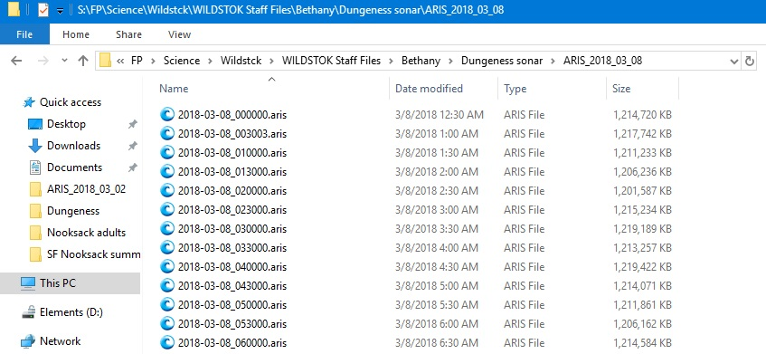

1. *Turn on background subtraction*. Background subtraction removes static objects from the image so that only objects that are in motion are shown when the image is playing.

Click on the background subtraction button circled in red below.

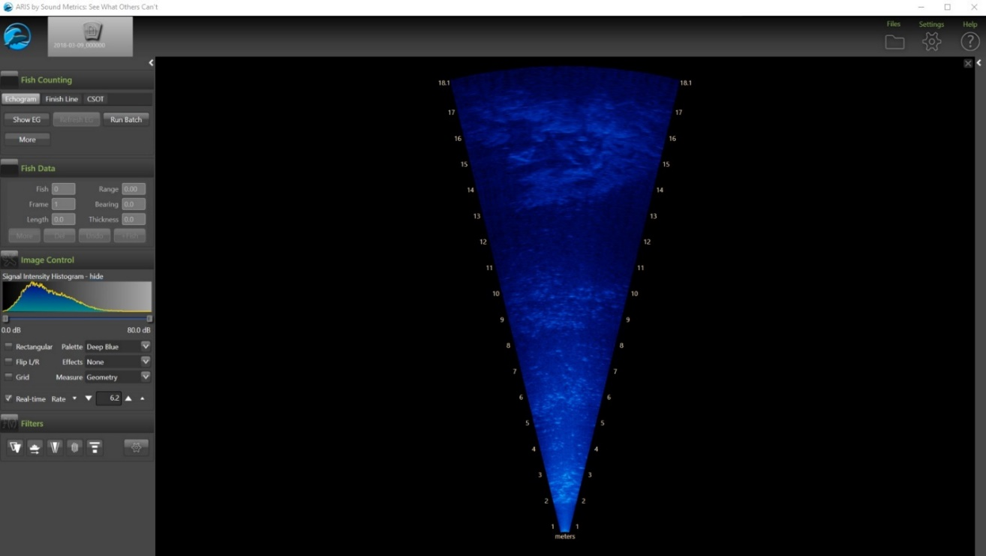

With background subtraction the SONAR imagery is black.

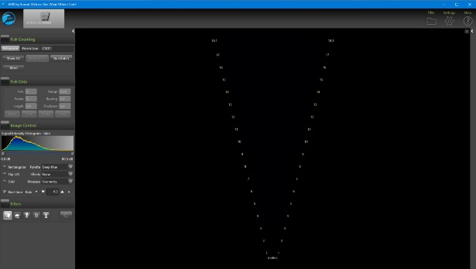

1. 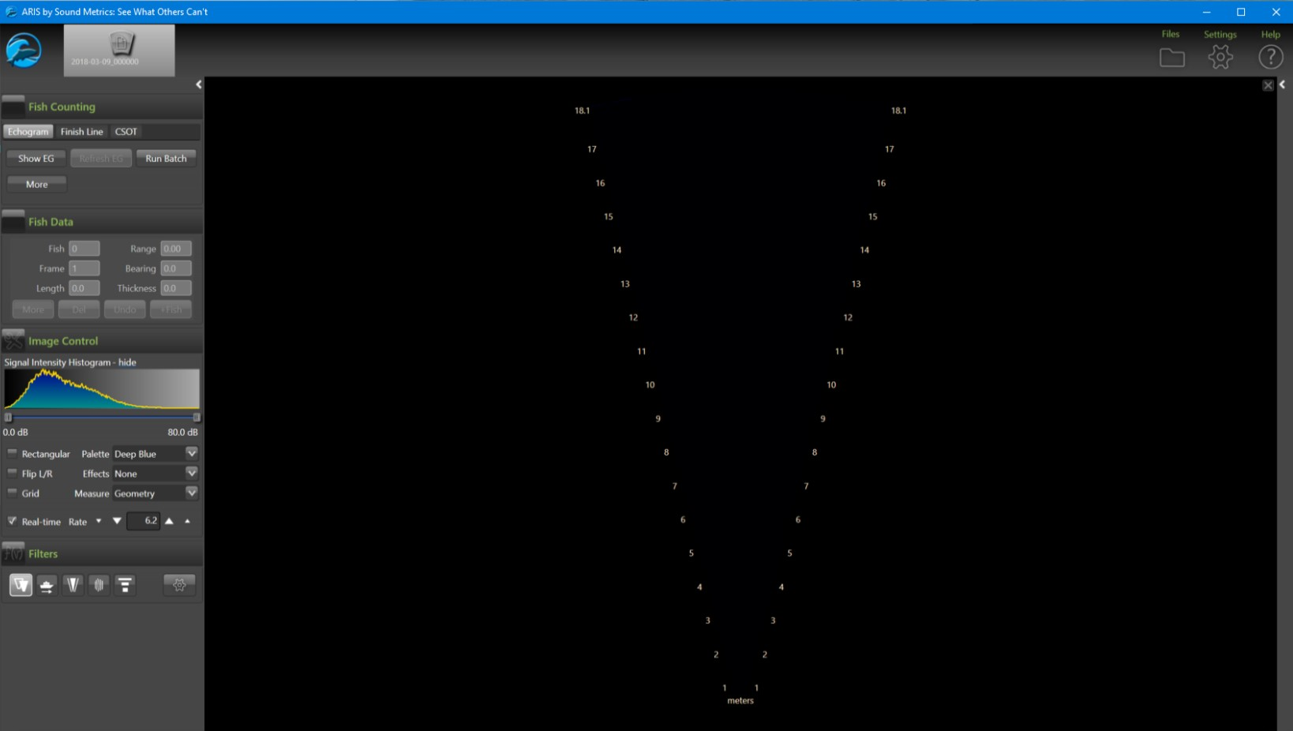*Click “Show EG”* in the top right corner of the screen. This will create an echogram for this 30 minute imagery file.

An echogram transforms the SONAR imagery into a graph of distance (y-axis) and time (x-axis). When an object moves across the SONAR beams it will leave a “track” that shows how long it took for the object to cross the beams and how far from the SONAR unit it was during that time.

Below is an example of an echogram with background subtraction. The top bar shows the master echogram for the entire 30 minute file. It will be blank if there are no objects in motion. The echogram page that is selected with the orange box is magnified in the large left panel.

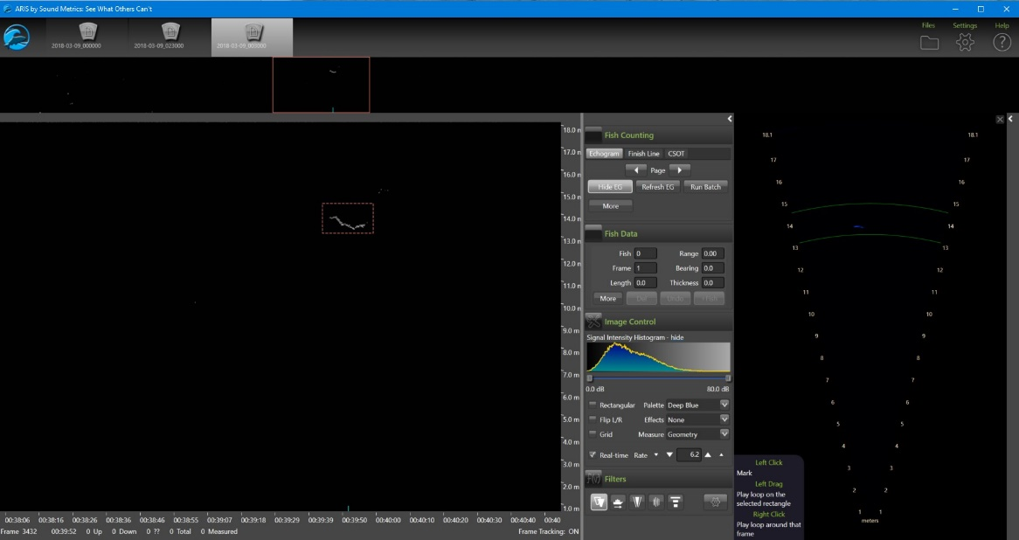

If you forgot to click the background subtraction button when you created the echogram, the echogram will have a lot of white and gray lines across it.

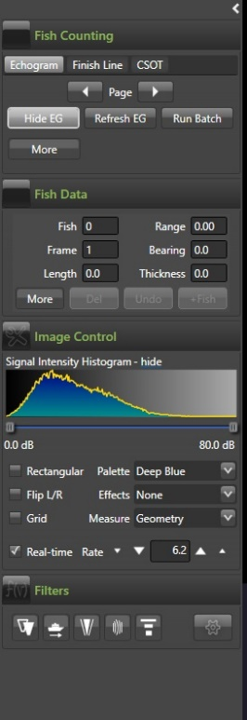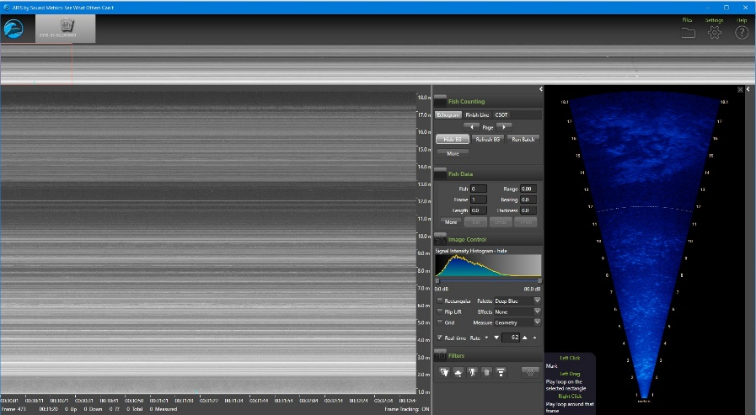

To remedy this, first click the “*background subtraction*” button, circled in red, and then click the “*Refresh EG*” button, also circled in red. This will recreate the echogram with background subtraction on.

When an echogram is created some echogram files will appear within the daily folder containing the .aris imagery files. Do not delete or move these .png files, otherwise the echogram will be deleted.

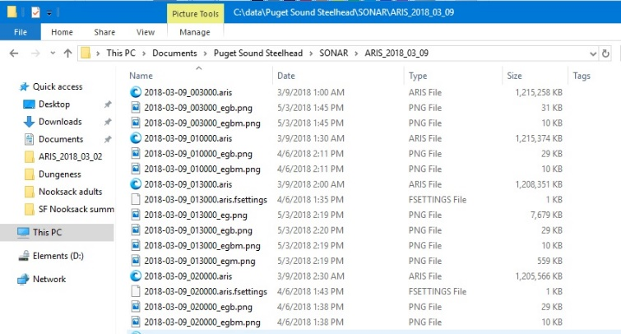

You can create batches of echograms at once for all the files within a day’s folder. This will save you time when you go to review the imagery for fish.

To run batches of echograms:

1. Open an .aris file and click “background subtraction.”
2. Click “Run batch” in the top left corner of the control panel. This will create an echogram for every .aris file in the daily folder that your open .aris file is located in.
3. Running a batch of echograms will slow down the computer and make it impossible to simultaneously review sonar imagery, so run batches of echograms overnight. Only run one day’s worth of echograms at once (one folder), otherwise ARISFish may crash.

**Some days will be reviewed by two reviewers (see data review assignments). For these days, before anyone reviews the data, make a clean copy of the day’s folder so that there are two copies with no fish marked.**

1. **Review and record data**

Once you’ve created an echogram you can then review the echogram alongside the SONAR imagery.

1. If you haven’t already, *open ARISFish and navigate to the .aris file you want to review*. Start with the first .aris file in that day’s folder.
2. *Click “Background Subtraction”*
3. *Click “Show EG”;* this will display the echogram
4. *Review the 30 minute echogram file, and* ***mark and measure all fish ≥ 45 cm. Only mark and measure fish that completely enter and exit the sonar beams. Do not mark fish that nose in and out, but do not completely move from one side to the other. Only mark holding fish once they move out of the beams.***
5. *Marking and measuring fish*
   1. Scroll through the entire master echogram by clicking the “Page” arrows within the “Fish Counting” section, circled in red below.
   2. Drag a small box around the fish in the magnified left panel of the echogram. This will loop the corresponding SONOR imagery in the right panel, which will be bounded by green lines.

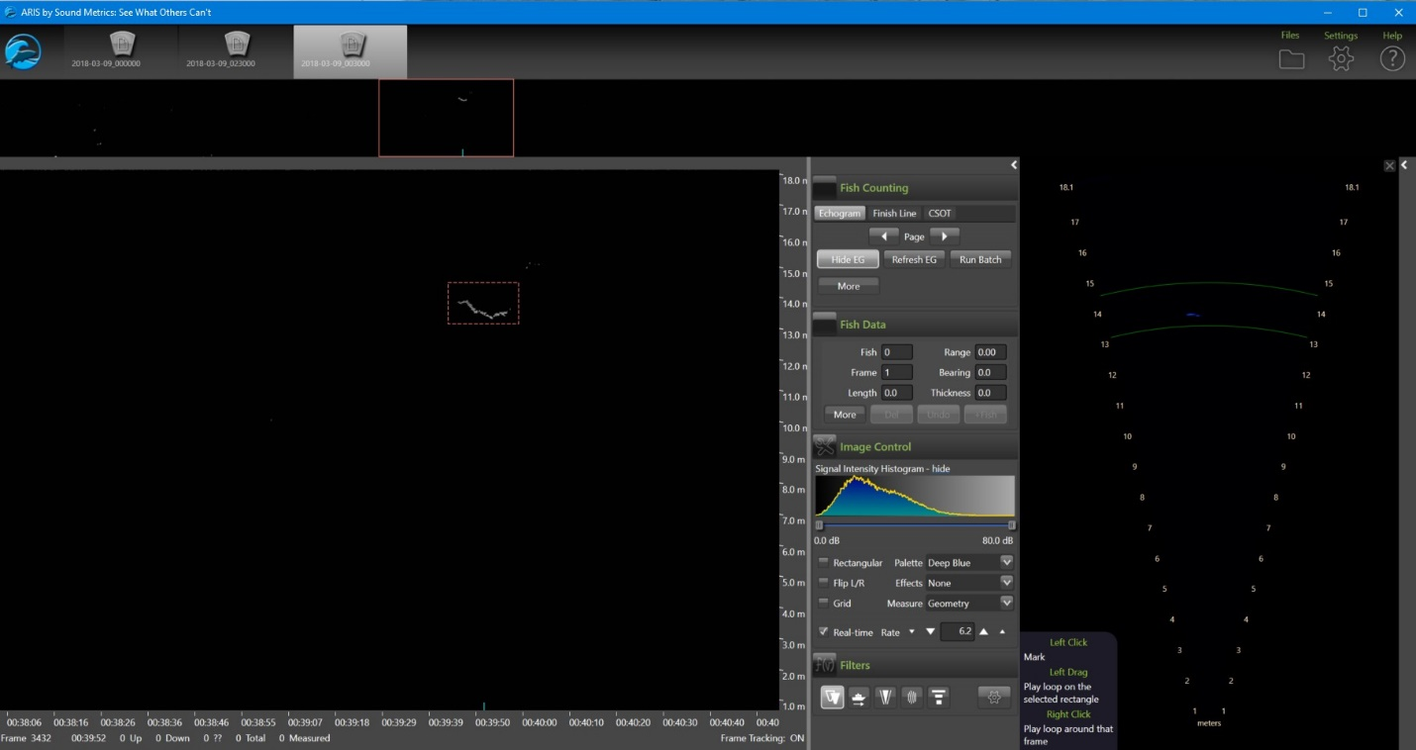

*To access the pause/play controls in the sonar imagery* right-click your mouse within the sonar imagery on the right-hand panel. If you can’t access the controls, try re-selecting a box within the echogram in the left panel, and then right-click in the right-hand sonar imagery panel.

*Zoom in* using the scroll bar on your mouse; use the mouse to drag the image for better viewing.

*Pause the imagery* by clicking the “pause” button, by right clicking within the imagery window, or by hitting the space bar.

*View frame by frame* by clicking the right or left arrow keys while paused or by clicking the forward and backward buttons.

*Toggle background subtraction ON and OFF* if needed to verify imagery is a fish.

* 1. **To mark a fish:** left-click near the fish in the imagery window. A red square mark will indicate the fish is marked. Delete mistaken marks by left-clicking inside the center of the red square. To delete more than one mark at once expand the Fish Counting section, and click either “Frame”, “Region”, or “All” to clear count within the file.

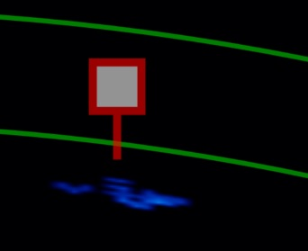

* 1. **To measure a fish:** right-click within the red square mark to select the fish for measuring. The inside of the red square will turn white, indicating the fish is selected. Left-click the head and then left-click the tail to finish the measurement. The length of the fish will be displayed in the Fish Data section. **To save the measurement click “+Fish” in the Fish Data section-** the square will turn to a circle and the measurement will be displayed. To remove a mark, click “Undo” or hit the “d” key to delete.

Measure with Background Subtraction ON if possible. Select the best image frame to measure the fish- one that clearly shows the head and tail, if possible.

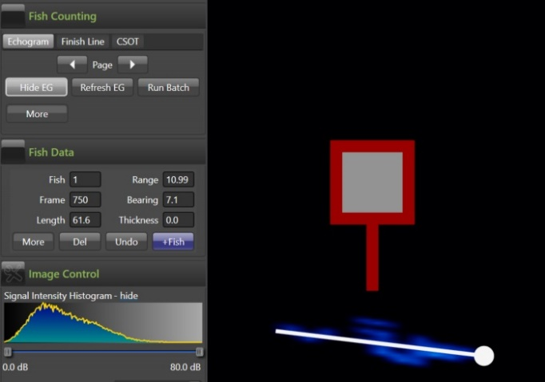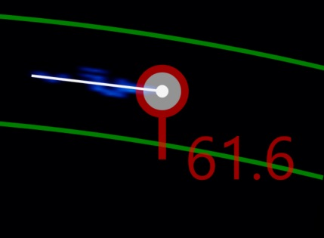

When you click the +Fish button in the Fish Data section, .txt and .xml files will be created within the daily folder that your open .aris file is located in. Do not delete these files, as this will delete the saved marked fish and measured fish.

1. *Record data in the* **Dungeness SONAR data** excel file.

Record a line of data for each fish marked and measured:

* *Date*
* *Hour* (general ARIS file 30 minute time, such as 14:00, 14:30)
* *Data Recorded* (Full, Partial, or No Data, depending if entire 30 minute file was recorded or not)
* *Data Reviewed* (First 30, Second 30, or No Data, depending if you reviewed the first/top 30 minutes of the hour, or the second/bottom 30 minutes, or if there wasn’t any data to review)
* *Observer* (observer’s initials)
* *Time* (time that fish passed SONAR and was marked)
* *Frame* (frame that fish passed SONAR and was marked)
* *Direction* (fish direction of travel: upstream, downstream)
* *Range* (Range, i.e. distance from SONAR unit)
* *Length* (length of fish in cm)
* *Confidence* (observer confidence: 1= extremely confident it’s a fish ≥ 45cm, 2= somewhat confident it’s a fish >45cm, 3= object of interest)
* *Comments* (notes, especially if not confident, also could make note of other fish in file that weren’t marked, s.a. large school of small fish moving downstream, or lots of fish milling or holding)

If no fish were observed in 30 minute file, record a line of data with No Fish in the Time column:

* *Date*
* *Hour*
* *Observer*
* *Data Recorded*
* *Data Reviewed*
* *Time* = No fish

1. **Keep track of data review progress, save and backup work**
2. Find data review assignments in the *Dungeness sonar data review* file, and record your data review progress

* *Data Recorded:* amount of data recorded for that date(24/hour period) = Full, Partial, or No Data
* *Data review method:* How much of the available recorded data was reviewed? = First 30 (first 30 minutes of hour), or Second 30 (second 30 minutes of hour, only review these for “full” data review days, or No Data if no data recorded to review
* *Data review completed:* enter Yes once you have completed review for that date
* *Comments:*  enter explanation if the full day was not recorded, or other comments

1. Frequently save work
2. Send email or text update to Bethany every two weeks with data review progress